**Team Members:** Thomas Bock, Ammar Ahmed, Tan Hua, Jan Michael Golez

.

**Group Meeting Minutes:**

* Testing CNC Laser.
* Attach Camera
* Complete Software Integration
* Begin Documentation
* Finalize Final Draft

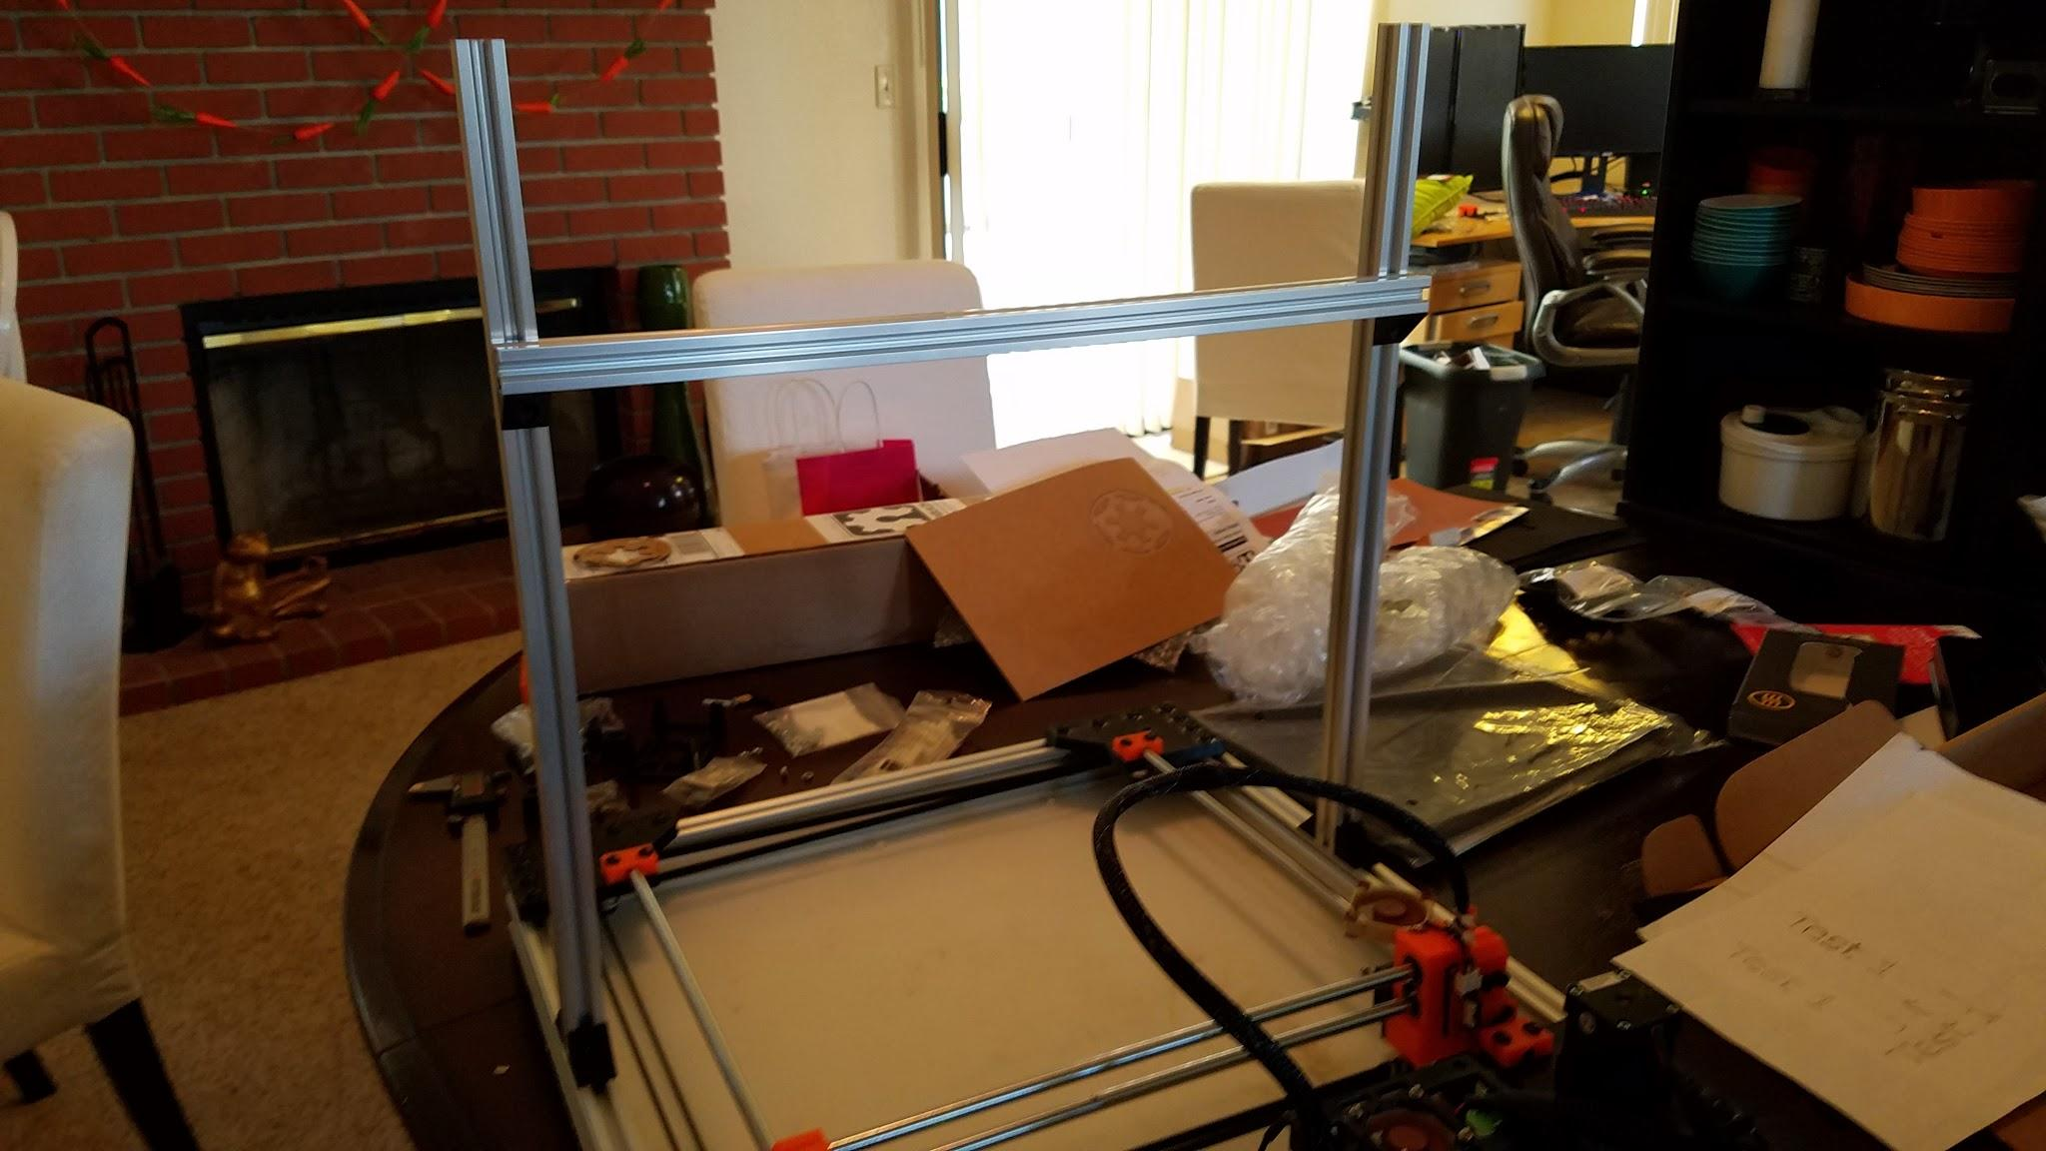

Camera mounting rail

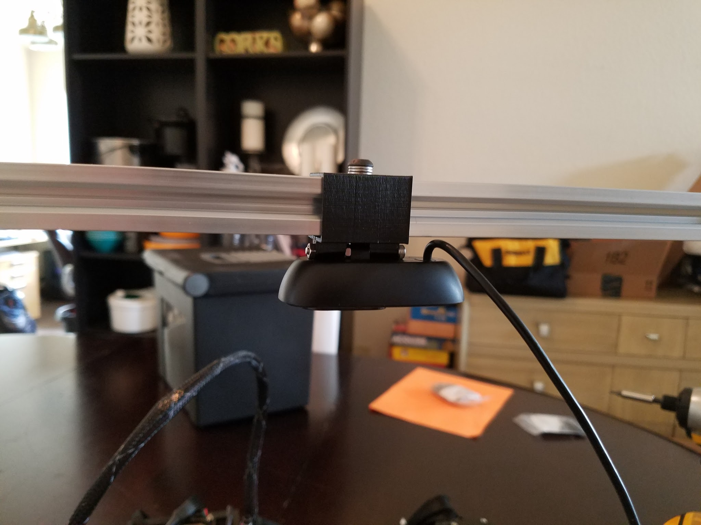

Camera mounted to rail

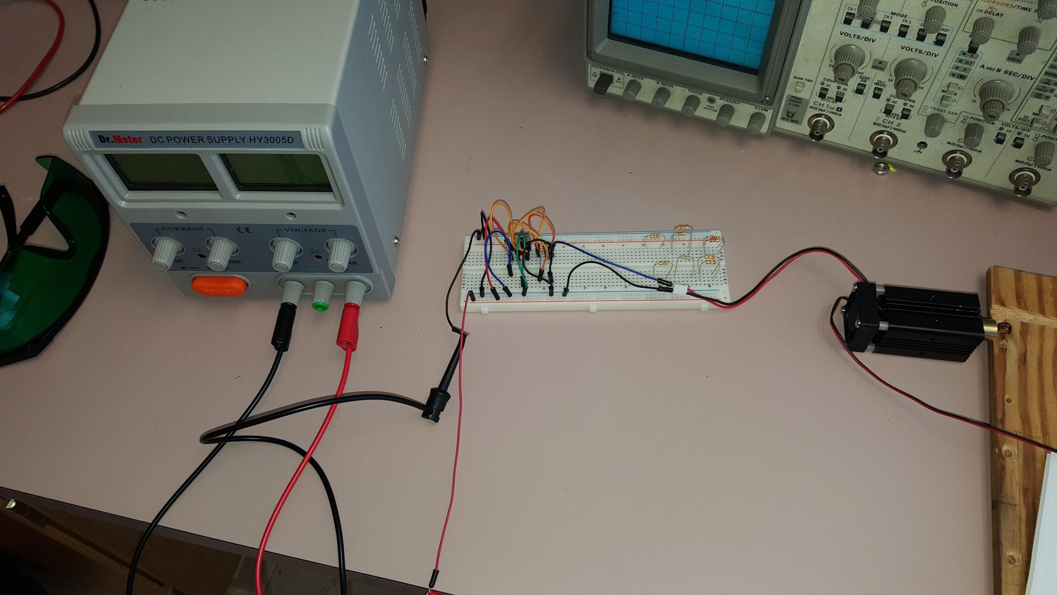

Prototype Laser Diode Driver.

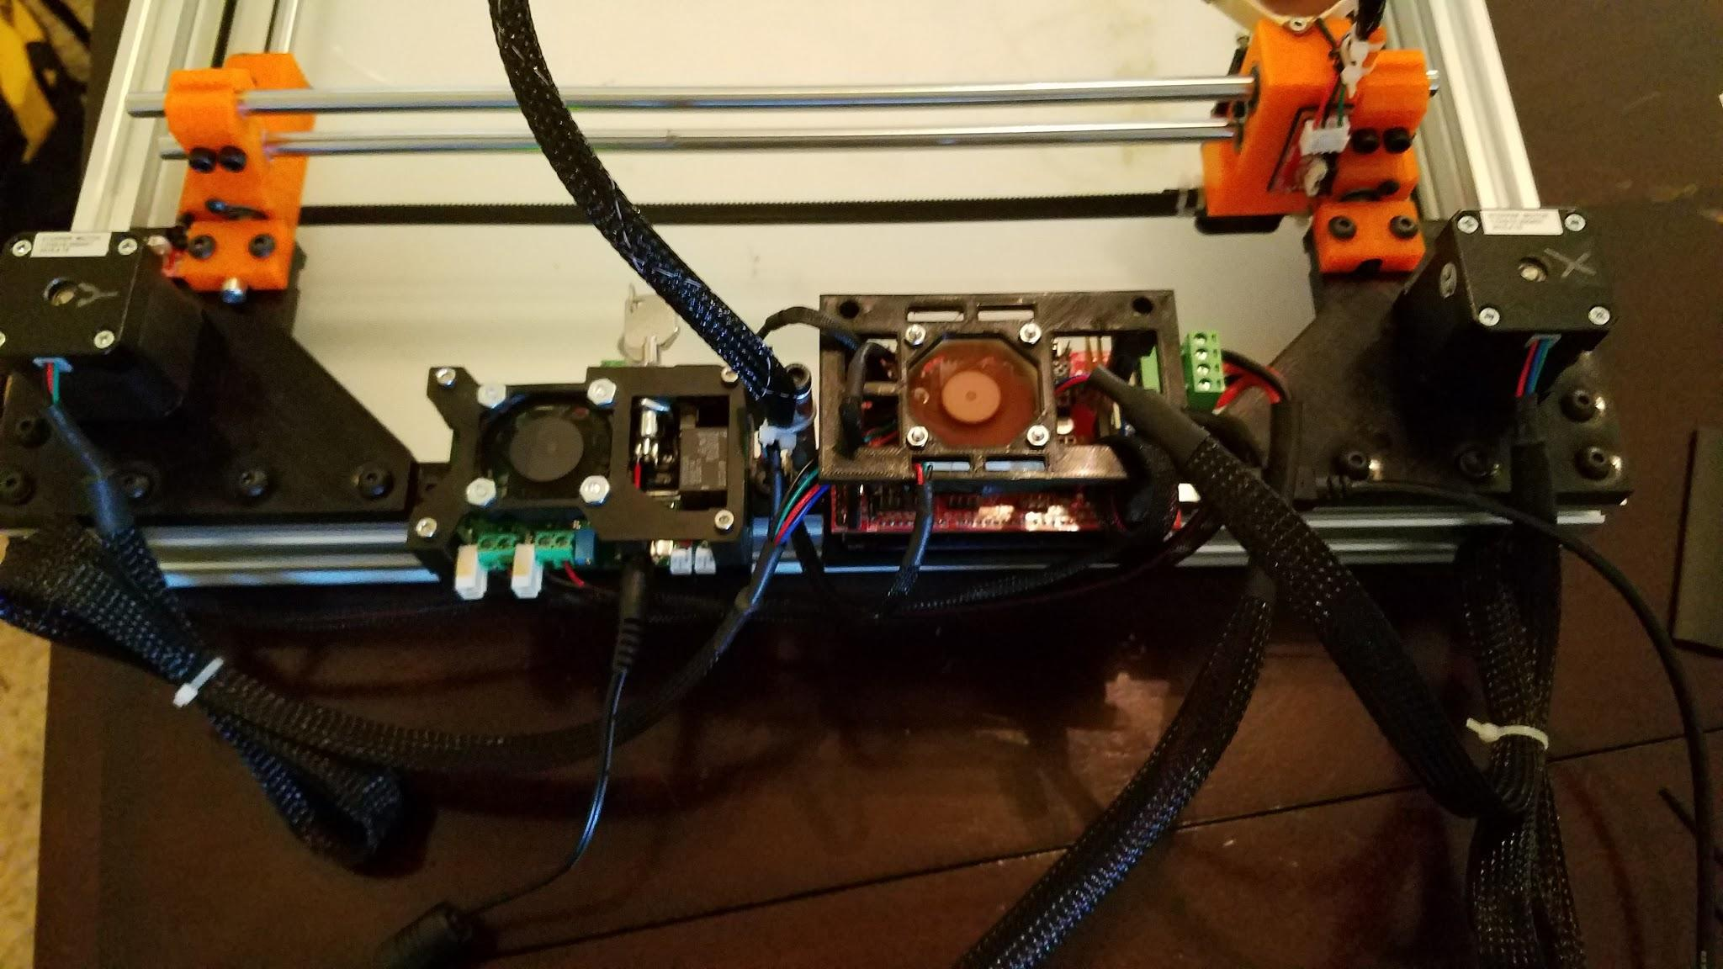

2.5 Amp Adjustable Safety Compliant Laser Diode Driver ;Ramps Board; Mounted to frame

**Summary of Team Tasks Assigned:**

1. Mechanics
2. Design and Assemble Camera mounting
3. Laser Diode
   1. Testing of CNC Laser..
4. Software
5. Improving rasterizing process.
6. Computer Vision
   1. Work on algorithm for edge detection( needed for dimension detection)

**Summary of Team Accomplishments:**

1. Mechanics
2. Design and Assemble Camera mounting
3. Laser Diode
4. Begin Documentations
5. Software
6. Rasterizing process has improved.
7. Computer Vision
8. An algorithm was found for filling circular objects but still working on the drawing box around the detected object.

**Tasks Assigned for Next reporting period:**

1. Mechanics
   1. Design and Build Camera mount
2. Laser Diode
3. Continue documentations
4. Purchase new module circuit
5. Software
6. Rasterizing mechanism needs to fixed and improved more.
7. Computer Vision
   1. Resolve the issue by finding the algorithm for filling the gaps or drawing a box around the detected object

**Issues:**

1. Rasterizing was not able to work properly.
2. Laser with Software: TTL integration with the board was not working; Laser Pinout was communicating with the Laser Diode( it wasn't turning on)
3. Camera Vision with Software: the camera couldn't detect dimensions and be outputted towards an Excel file
4. More research is needed for a new module.
5. Although 1st integration was successful, we need to be able to ensure all four parts communicate. This will require thorough analysis and lots of debugging.
6. Testing M

**Individual Summary (cont.)**

**Name:** Thomas Bock

**Tasks Assigned for this reporting period:**

1. Integrate camera into rest of system.

**Accomplishments this reporting period:**

1. Integrate camera into rest of system.

**Issues:**

1. Issues with sizing mount properly to hold camera tight, but was taken care of.
2. Also helped on trying to figure out laser engraving. Still have the issue of laser power not varying properly, but did make some headway on getting the motion correct for engraving. After some more collaboration with Tan on this issue I think it can be resolved.

**Tasks Assigned for Next reporting period:**

1. Testing of complete device
2. Sort out any bugs with software
3. Sort out any bugs in camera system

**Individual Summary (cont.)**

**Name:** Jan Michael Golez

**Tasks Assigned for this reporting period:**

1. Testing of CNC Laser.

**Accomplishments this reporting period:**

1. Begin Documentations

**Issues:**

1. More research is needed for a new module

**Tasks Assigned for Next reporting period:**

1. Continue documentations
2. Purchase new module circuit

**Individual Summary (cont.)**

**Name:** Tan Hua

**Tasks Assigned for this reporting period:**

1. Complete process from design to execution

**Accomplishments this reporting period:**

1. Rasterizing process has improved.

**Issues:**

1. The system has not worked properly when rasterizing yet.

**Tasks Assigned for Next reporting period:**

1. Complete rasterizing process.
2. Do more testing with different design to improve performance.

**Individual Summary (cont.)**

**Name:** Ammar Ahmed

**Tasks Assigned for this reporting period:**

1. Calibrating the camera to get dimensions in real world unit.

**Accomplishments this reporting period:**

1. Calibration is still in progress. The camera does get the dimensions, however, the readings are not accurate enough and has $±2 cm$ error.

**Issues:**

1. Dimensions readings are not accurate enough because of the calibration factor.

**Tasks Assigned for Next reporting period:**

1. Continue calibrating the camera to get the exact dimensions in real world unit.